Introduction
Navigating an unfamiliar school campus as a new student or a visitor, can often be daunting. Although map programs outside of the school, such as Google Maps and Citymapper, work great for outdoor use, they lack the specific details that are needed in navigating a school environment, such as classroom numbers or buildings. And while there is an existing map of the school, it can be hard to use especially if there is no prior knowledge of the school.
This project aims to solve this problem by creating a mobile application that provides a wayfinding experience that is similar to preexisting programs, so that navigating the school can be more intuitive.

Contents
Introduction 1
1. Analysis 3
1.1 Existing Solutions 3
Google Maps 3
Smart Networked Environments 3
1.2 Questionnaire 4
Questions & User Responses 4
1.3 Project Aims 6
Interactive Map 6
Shortest Path Finding 6
Search Functionality 6
Ease of Use 6

1. Analysis

1.1 Existing Solutions

Google Maps
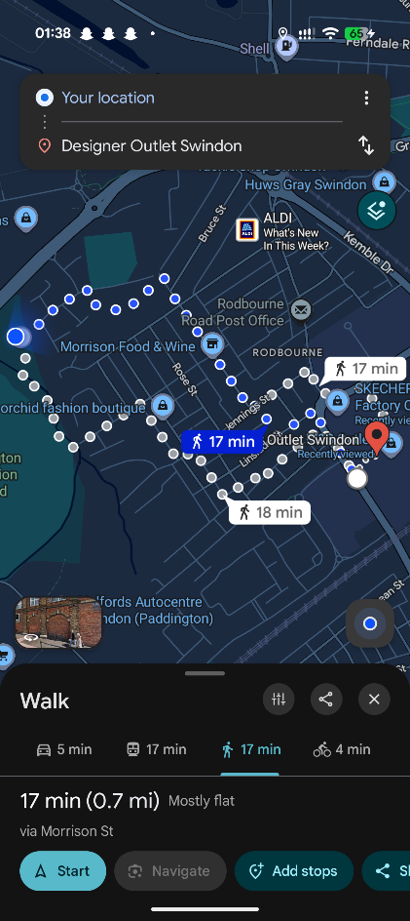
Google Maps is probably the most widely known mapping application offering route planning for several different modes of transport, including by foot, car, and public transport. It primarily focuses on outdoor navigation, so its indoor data can be lacking.
The design of the user interface is intuitive, as most text elements are accompanied by icons, making their function easy to understand which is especially important when finding your way to a location in a rush.
For walking, it also has turn-by-turn directions, giving clear guidance on where to make a turn.

Smart Networked Environments
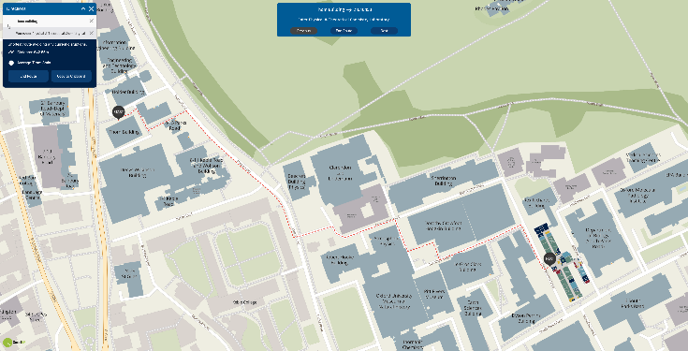
A mapping service specifically designed for indoor navigation and is mainly used by universities. It has an interactive map where you can go inside a building and view the individual rooms and switch between different floors.
It also allows you to get directions to rooms, but I have found this feature to be quite lacking, as it does not have turn-based directions and the “get directions” button would sometimes just not work.

1.2 Questionnaire
To gather insight on what features would be most useful, I sent out a survey to the school’s year 7 and 8s and asked for feedback on potential features. The specific year groups were chosen as they were the newest and would the least familiar with the school, meaning they are the most likely users of the app.

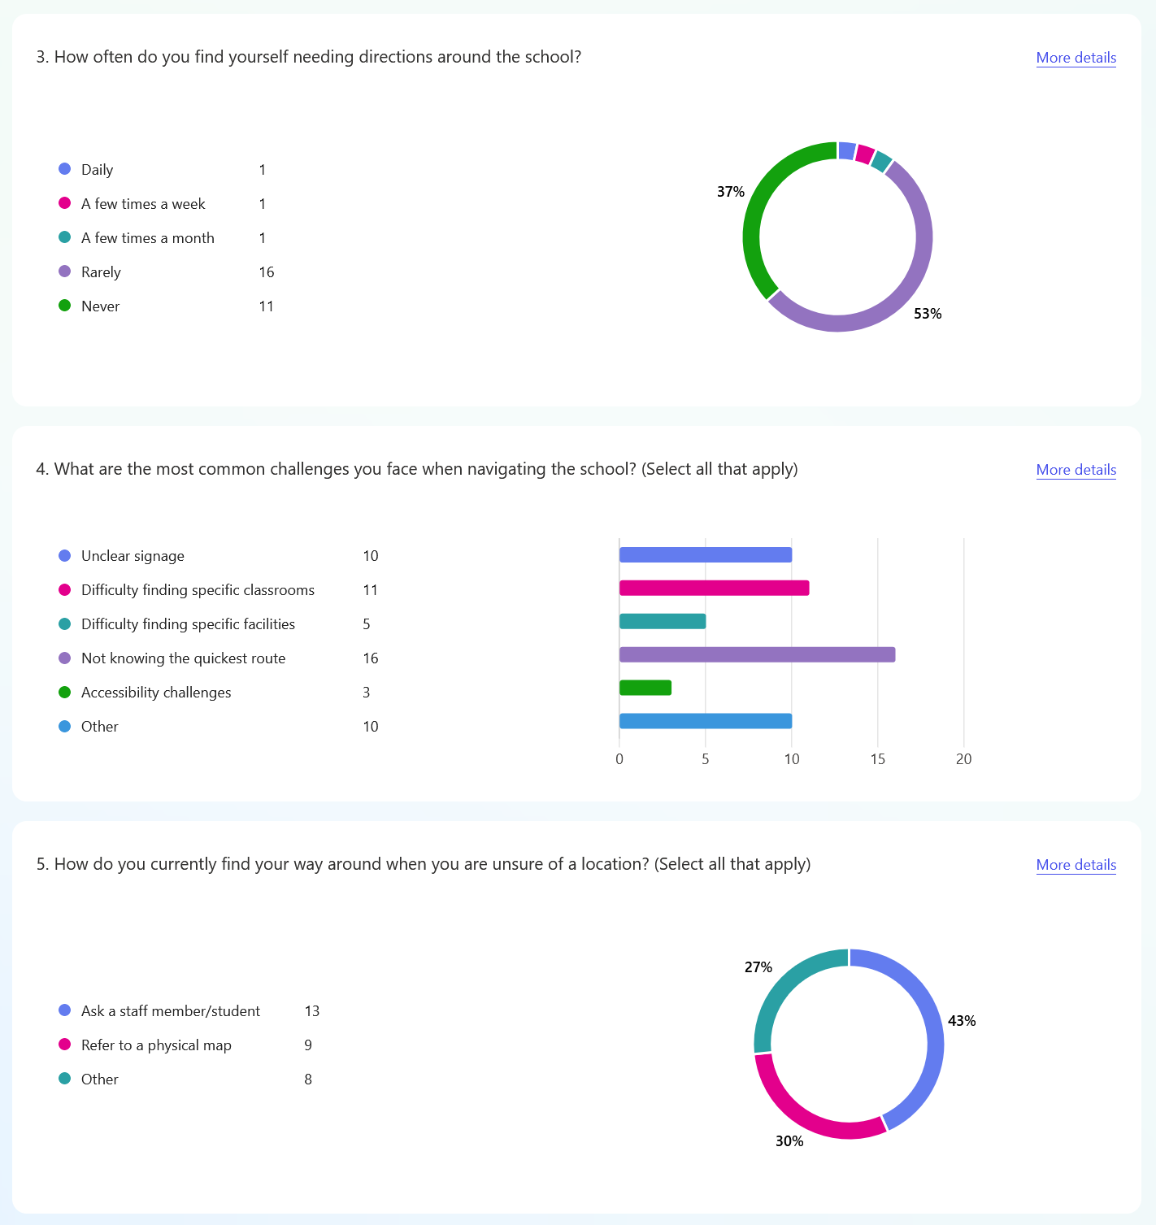
Questions & User Responses

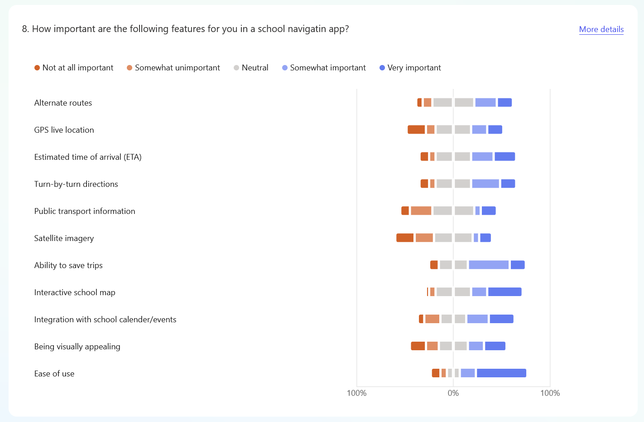
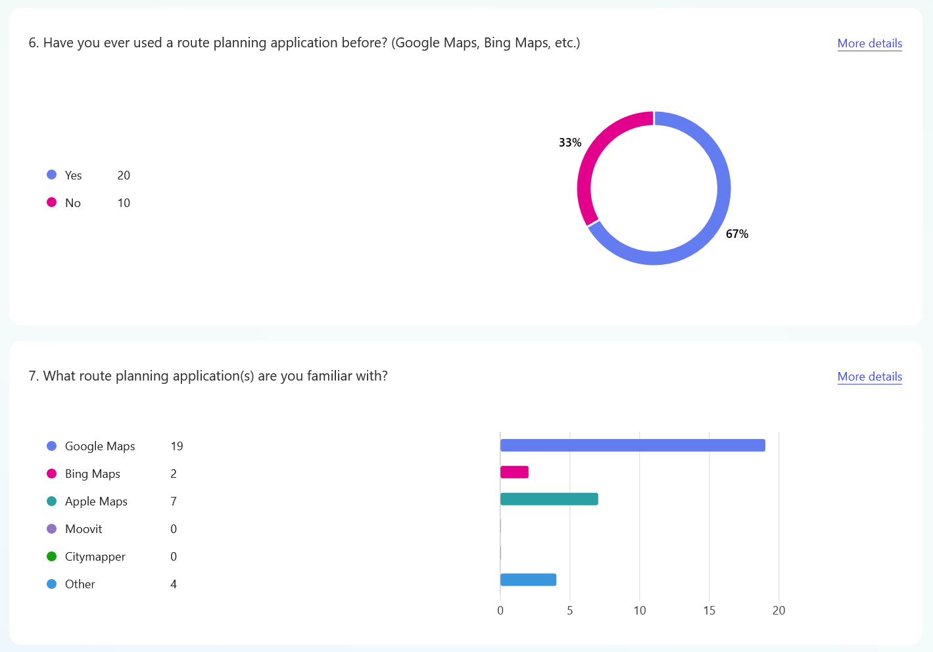

1.3 Project Aims
With the results from the survey, I have come up with the following key objectives:

Interactive Map
The user should be able to see their live location on a digital to-scale map that shows classrooms and facilities such as toilets, canteens, etc. Like preexisting applications that the user would be familiar with, the map should be interactive, meaning the user can zoom in/out and pan to explore the school campus. This is a vital feature as most of the students surveyed considered it to be important.

Shortest Path Finding
The app should allow the user to input a destination and find the quickest way to get there, it should then calculate an estimated time of arrival and display a list of directions for the user to follow. This is also an important feature as the survey indicates that not knowing the quickest route is the most common challenge faced by students when navigating.

Search Functionality
The user should be able to search for a room/facility by its number, name, or subject, and the location of the room should be shown on the map, allowing the user to locate the room.

Ease of Use
This is the most important ‘feature’ based on the responses to question 8, so the app should have an intuitive design, and be consistent with the user’s expectations from their experience with other mapping apps. This would minimise the app’s learning curve and make it as accessible as possible to its users.

1.4 Limitations

Timetable Synchronisation
While this feature would be very useful as it would allow the user to quickly select their next lesson’s location without having to search for it, due to Arbor (the management software used by the school) not having a public API and Microsoft Exchange requiring permission from the school’s admin.

2. Design

2.1 Overview
The app is implemented using Flutter, an application framework for the Dart language developed by Google. It was chosen because of its cross-platform support (single codebase for Android and iOS) and Dart is similar to other C-style languages I’m already familiar with.
The other framework I considered was React Native, but it was not chosen due to its use of JavaScript which I have found to be hard to debug and its steeper learning curve.

2.2 User Interface
Since Flutter does not have a drag-and-drop UI builder where I can experiment with different UI elements and see what they would look like, I used Figma to design and prototype the user interface of the app.

Colours
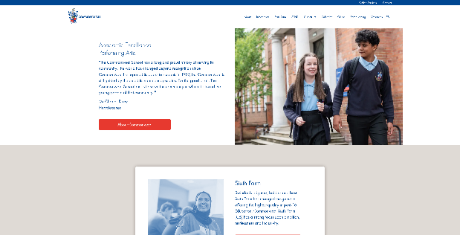
I used the school’s existing blue and red theme to make the app feel consistent with the school’s branding, which I think emphasises to the user that the impression that the app is tailored for the school.
School website
I chose to use blue as the primary colour with the red acting as an accent colour to highlight high priority actions in the app, making it easier to locate where to click.

Explore Page
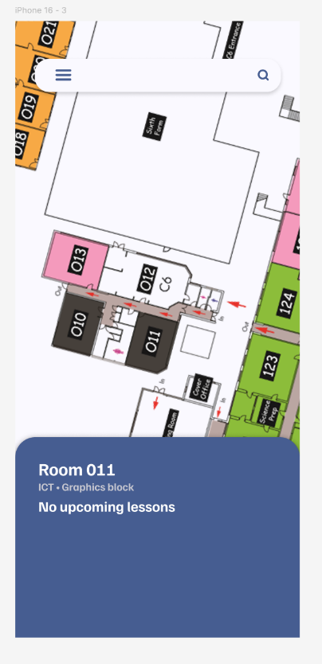
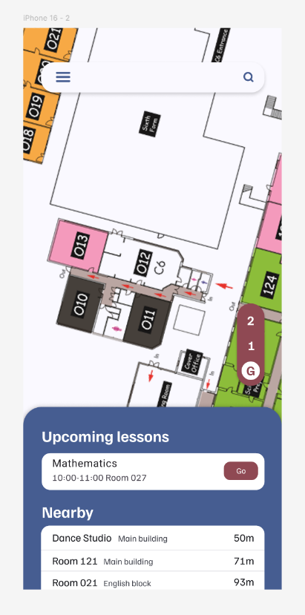
This is the main page of the program where the user can move the map around and explore different parts of the school campus. It consists of a map which acts as a base layer and other UI elements that are layered on top of it.
The list of upcoming lessons will allow the user to quickly get directions to their next lesson without having to search for it, which will be important when in a rush.
The user will also be able to tap on a room to select it and view its details.

Search Page
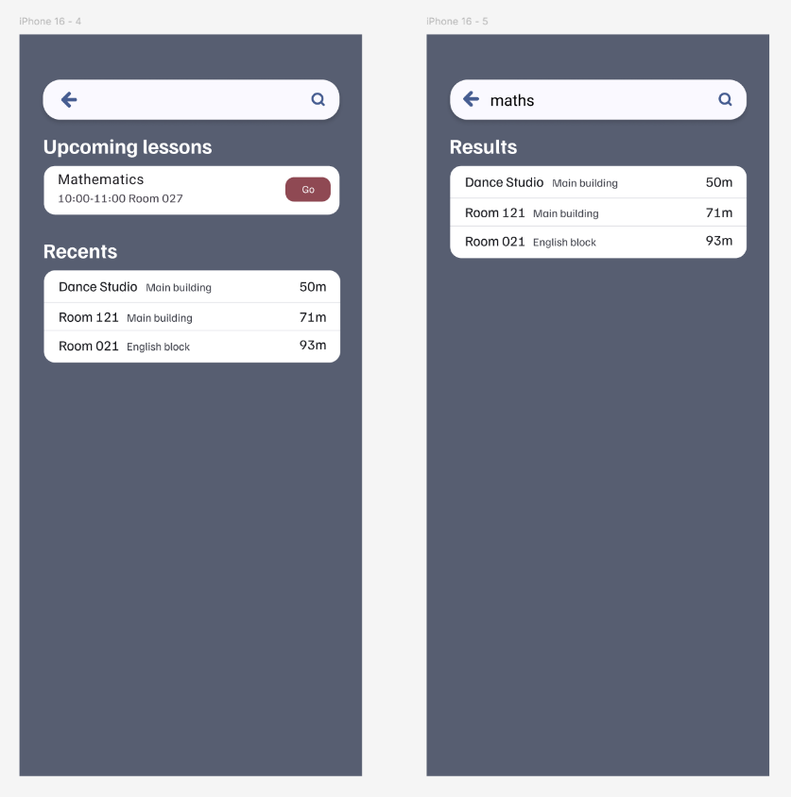
Upon tapping the search bar on the top of the main page, the user enters the search page where they can search for a room by its number, location, or subject.

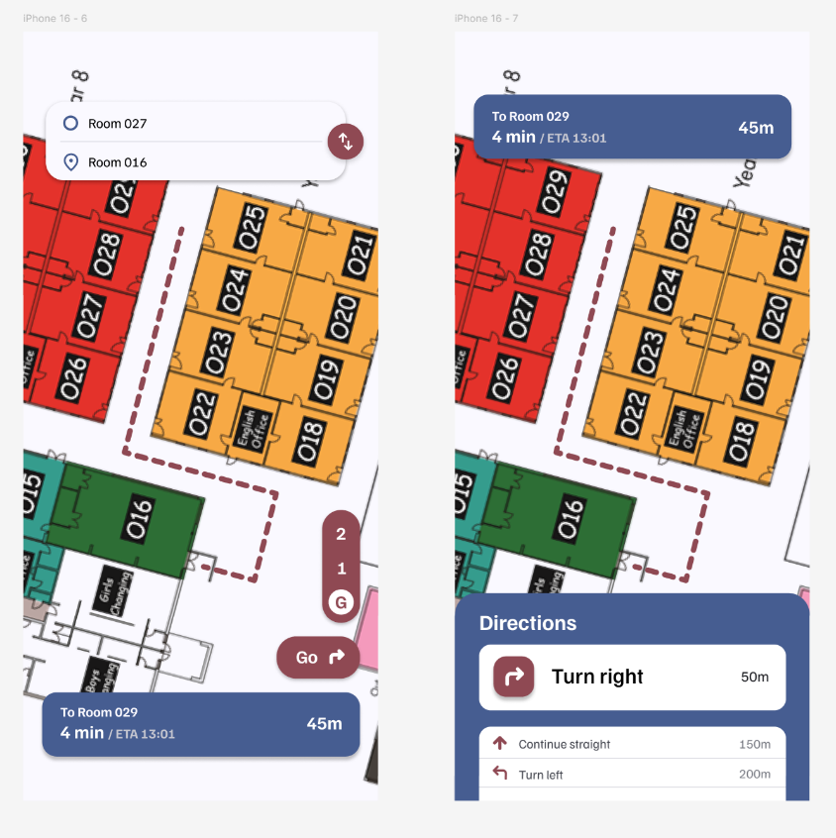
Route Preview and Navigation
TODO

2.3 Map Data

Digitising the School
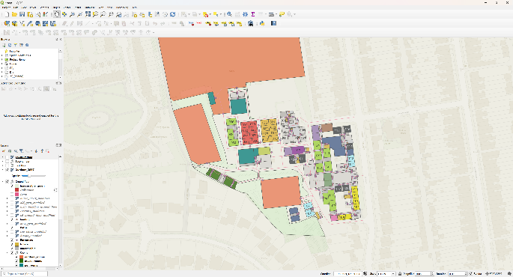
Since there is no existing digital public data for the school’s layout, I had to create my own digital version of the school map. To do this, I used QGIS – an open-source geographic information system (GIS) software that supports creating and analysing geospatial data, and the map created can then be exported in the GeoPackage file format which can be read by other programs.
The digitised map of the school viewed in QGIS
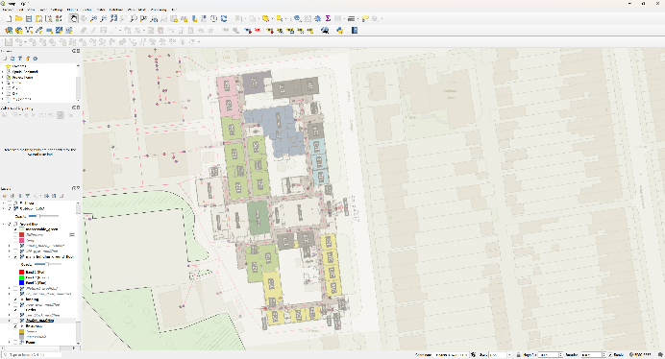
The digitisation process consists of georeferencing (the process of adding coordinates to an image) the existing maps and overlaying it on top of the world map, then mapping out the geographical features such as rooms and buildings using the polygon tool, followed by adding paths and entrances to the rooms.
The existing map of the school overlayed on top of the world map
A great feature of QGIS is that attributes can be attached to objects, meaning that data such as room numbers and toilet gender can be added during this stage, and minimal additional data is needed when parsing the exported data.

Storing the Data
After creating the map in QGIS, the individual layers are exported and grouped by their floor.
├───0
│ buildings.gpkg - required
│ entrances.gpkg - required
│ inaccessible.gpkg - required
│ landings.gpkg - required
│ paths.gpkg – required
│ toilets.gpkg - required
│ [subject]_rooms.gpkg
│ ...
│
├───1
│ ...
│ ...
│ ...
│
└───2
...
...
...

For each floor, there are:
- buildings.gpkg – stores buildings as polygons, with the required attribute name
- entrances.gpkg – stores the entrances to the rooms, with the required attribute room (the room which the entrance belongs to, more on how this works later) and the optional attribute name
- inaccessible.gpkg – stores the areas that inaccessible (like an obstacle or a room that is only accessible to staff); has no attributes
- landings.gpkg – stores the landings of the staircases, with the attribute staircase (index of the staircase it belongs to)
- paths.gpkg – stores the paths that the app uses for navigation with the optional attribute name
- toilets.gpkg – stores the toilets, with the required attribute type (encodes the type of the toilet, such as accessible, staff and so on) and the optional attribute name
- [subject]_rooms.gpkg - stores each subject’s rooms, with at least one of number and name
The room attribute of an entrance is used to link an entrance to a room/building/toilet. This is done by setting it to:
- the number or name of the room – if the entrance belongs to a room
- the name of the building – if the entrance belongs to a building
- the fid (id autogenerated by QGIS) of the toilet – if the entrance belongs to a toilet

Parsing the Generated Data
Dart unfortunately does not have great support of GeoPackages, so I wrote a Python script that converts them into a single SQLite database, a format which Dart has great support for.
While this does introduce an extra layer of complexity, it does have several benefits:
- Potential errors in the map can be detected by the script automatically and be corrected before even running the actual app
- Greatly reduces size of the map since only the relevant data is converted (from ~5000KB to ~200KB)
- Only one file will need to be copied to the app when I modify the map (instead of ~50 individual files) 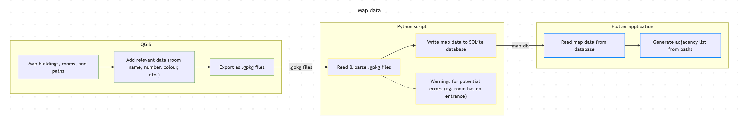

2.4 Data Structures

Database Schema
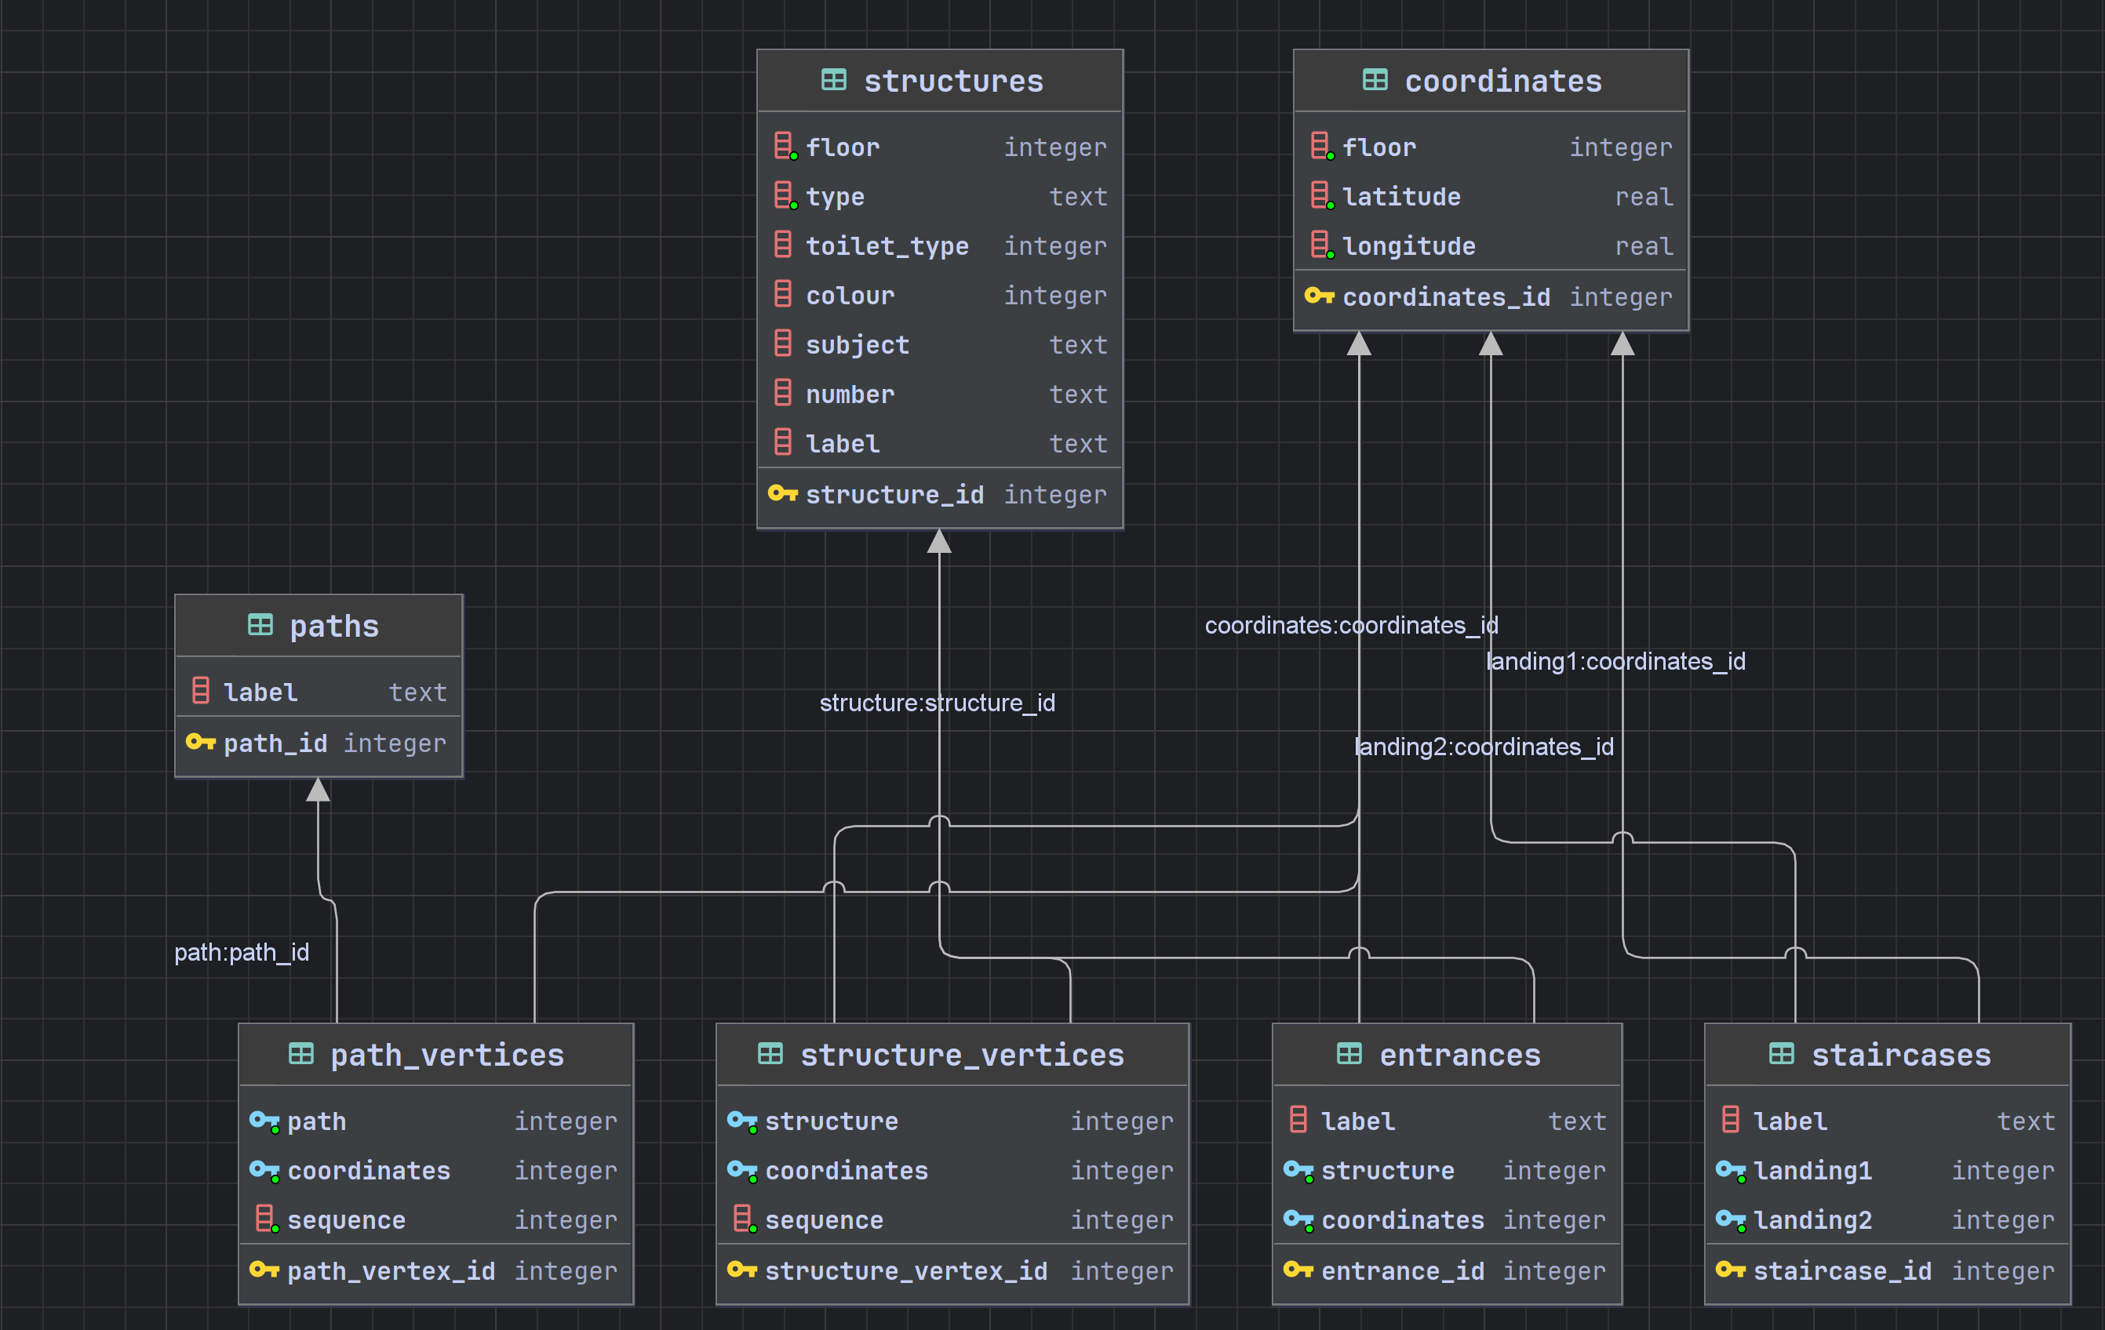

Conversion Script
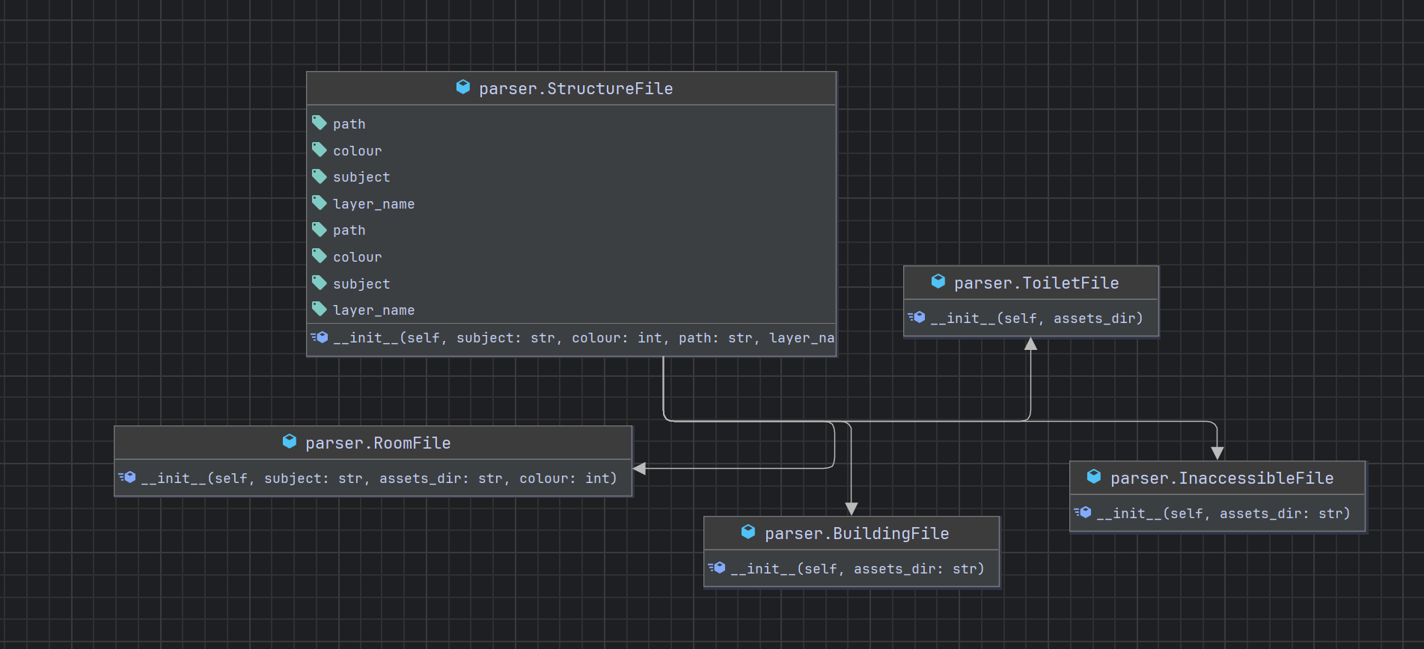

Main App

2.5 Algorithms

A*

Turn-by-Turn Directions

Ray Casting

Route Adjustment

3. Technical Solution

3.1 Conversion Script (Python)

main.py

import time
from parser import Parser, Floor, StructureType, RoomFile
assets_dir = "./assets/"
ground_floor_room_files = [
RoomFile("art", assets_dir + "0/", 0xfaa2c1),
RoomFile("design", assets_dir + "0/", 0x862e9c),
RoomFile("ICT", assets_dir + "0/", 0x343a40),
RoomFile("science", assets_dir + "0/", 0x9dd73b),
RoomFile("maths", assets_dir + "0/", 0xe6403c),
RoomFile("english", assets_dir + "0/", 0xe5b636),
RoomFile("general", assets_dir + "0/", 0xdbdbdb),
RoomFile("catering", assets_dir + "0/", 0x862e9c),
RoomFile("curriculum support", assets_dir + "0/", 0x405c8f),
RoomFile("dance", assets_dir + "0/", 0x276b04),
RoomFile("humanities", assets_dir + "0/", 0xa1efff),
RoomFile("MFL", assets_dir + "0/", 0xebe500),
RoomFile("social sciences", assets_dir + "0/", 0xe46cb3),
RoomFile("PE", assets_dir + "0/", 0x008080),
RoomFile("drama", assets_dir + "0/", 0x276b04),
RoomFile("music", assets_dir + "0/", 0x276b04),
RoomFile("outdoor", assets_dir + "0/", 0xdbdbdb),
]
first_floor_room_files = [
RoomFile("art", assets_dir + "1/", 0xfaa2c1),
RoomFile("general", assets_dir + "1/", 0xdbdbdb),
RoomFile("ICT", assets_dir + "1/", 0x343a40),
RoomFile("curriculum support", assets_dir + "1/", 0x405c8f),
RoomFile("humanities", assets_dir + "1/", 0xa1efff),
RoomFile("social sciences", assets_dir + "1/", 0xe46cb3),
RoomFile("catering", assets_dir + "1/", 0x862e9c),
]
second_floor_room_files = [
RoomFile("general", assets_dir + "2/", 0xdbdbdb),
RoomFile("music", assets_dir + "2/", 0x276b04),
RoomFile("drama", assets_dir + "2/", 0x276b04)
]
floors = [
Floor(ground_floor_room_files, assets_dir + "0/"),
Floor(first_floor_room_files, assets_dir + "1/"),
Floor(second_floor_room_files, assets_dir + "2/"),
]
# Named staircases are supported but none of the ones in the school have names
staircases = [""] * 10
landing_files = [
assets_dir + "0/landing.gpkg",
assets_dir + "1/landing.gpkg",
assets_dir + "2/landing.gpkg",
]
db = Parser("map.db")
start = time.time_ns()
for i, floor in enumerate(floors):
db.add_paths(floor.path_file, i)
db.add_structures(floor.room_files, StructureType.room, floor.entrance_file, i)
db.add_structures([floor.building_file], StructureType.building, floor.entrance_file, i)
db.add_structures([floor.inaccessible_file], StructureType.inaccessible, floor.entrance_file, i)
db.add_structures([floor.toilet_file], StructureType.toilet, floor.entrance_file, i)
db.add_staircases(landing_files, staircases)
db.commit()
end = time.time_ns()
time_taken = end - start
print(f"Data conversion complete. Took {int((time_taken / 1_000_000))}ms. \n"
f"Parsed {len(db.coordinates_table.table)} coordinates, {len(db.structure_table.table)} rooms and {len(db.path_table.table)} paths.")

parser.py
import math
from tables import Coordinates, Path, PathVertex, Structure, StructureVertex, Entrance, Table, Staircase, ToiletType, StructureType
from dataclasses import dataclass
from enum import Enum
import sqlite3
import fiona
@dataclass
class StructureFile:
path: str
colour: int
subject: str
layer_name: str
def __init__(self, subject: str, colour: int, path: str, layer_name: str):
self.path = path.lower()
self.colour = colour
self.subject = subject
self.layer_name = layer_name.lower()
@dataclass
class RoomFile(StructureFile):
def __init__(self, subject: str, assets_dir: str, colour: int):
path = assets_dir + subject + "_rooms.gpkg"
layer_name = subject + "_rooms"
super().__init__(subject, colour, path, layer_name)
@dataclass
class BuildingFile(StructureFile):
def __init__(self, assets_dir: str):
super().__init__("buildings", 0xced4da, assets_dir + "buildings.gpkg", "buildings")
@dataclass
class InaccessibleFile(StructureFile):
def __init__(self, assets_dir: str):
super().__init__("inaccessible", 0xb8b8b8, assets_dir + "inaccessible.gpkg", "inaccessible")
@dataclass
class ToiletFile(StructureFile):
def __init__(self, assets_dir):
super().__init__("toilet", 0xdbdbdb, assets_dir + "toilets.gpkg", "toilets")
@dataclass
class Floor:
room_files: list[StructureFile]
building_file: BuildingFile
inaccessible_file: InaccessibleFile
toilet_file: ToiletFile
path_file: str
entrance_file: str
def __init__(self, room_files: list[StructureFile], assets_dir: str):
self.room_files = room_files
self.building_file = BuildingFile(assets_dir)
self.inaccessible_file = InaccessibleFile(assets_dir)
self.toilet_file = ToiletFile(assets_dir)
self.path_file = assets_dir + "paths.gpkg"
self.entrance_file = assets_dir + "entrances.gpkg"
class Parser:
coordinates_table: Table[Coordinates]
path_table: Table[Path]
path_vertex_table: Table[PathVertex]
structure_table: Table[Structure]
structure_vertex_table: Table[StructureVertex]
entrance_table: Table[Entrance]
staircase_table: Table[Staircase]
entrance_lookup: dict[int, dict[str, list[Entrance]]]
connection: sqlite3.Connection
def __init__(self, db: str):
self.coordinates_table = Table()
self.path_table = Table()
self.path_vertex_table = Table()
self.structure_table = Table()
self.structure_vertex_table = Table()
self.entrance_table = Table()
self.staircase_table = Table()
self.entrance_lookup = {}
self.connection = sqlite3.connect(db)
self.connection.cursor().executescript("""
PRAGMA foreign_keys = ON;
DROP TABLE IF EXISTS entrances;
DROP TABLE IF EXISTS structure_vertices;
DROP TABLE IF EXISTS path_vertices;
DROP TABLE IF EXISTS structures;
DROP TABLE IF EXISTS paths;
DROP TABLE IF EXISTS staircases;
DROP TABLE IF EXISTS coordinates;
CREATE TABLE paths (
path_id INTEGER PRIMARY KEY,
label TEXT
);
CREATE TABLE coordinates (
coordinates_id INTEGER PRIMARY KEY,
floor INTEGER NOT NULL,
latitude REAL NOT NULL,
longitude REAL NOT NULL
);
CREATE TABLE path_vertices (
path_vertex_id INTEGER PRIMARY KEY,
path INTEGER NOT NULL,
coordinates INTEGER NOT NULL,
sequence INTEGER NOT NULL,
FOREIGN KEY (path) REFERENCES paths(path_id),
FOREIGN KEY (coordinates) REFERENCES coordinates(coordinates_id)
);
CREATE TABLE structures (
structure_id INTEGER PRIMARY KEY,
floor INTEGER NOT NULL,
type TEXT NOT NULL,
toilet_type INTEGER,
colour INTEGER,
subject TEXT,
number TEXT,
label TEXT
);
CREATE TABLE structure_vertices (
structure_vertex_id INTEGER PRIMARY KEY,
structure INTEGER NOT NULL,
coordinates INTEGER NOT NULL,
sequence INTEGER NOT NULL,
FOREIGN KEY (structure) REFERENCES structures(structure_id),
FOREIGN KEY (coordinates) REFERENCES coordinates(coordinates_id)
);
CREATE TABLE entrances (
entrance_id INTEGER PRIMARY KEY,
label TEXT,
structure INTEGER NOT NULL,
coordinates INTEGER NOT NULL,
FOREIGN KEY (structure) REFERENCES structures(structure_id),
FOREIGN KEY (coordinates) REFERENCES coordinates(coordinates_id)
);
CREATE TABLE staircases (
staircase_id INTEGER PRIMARY KEY,
label TEXT,
landing1 INTEGER NOT NULL,
landing2 INTEGER NOT NULL,
FOREIGN KEY (landing1) REFERENCES coordinates(coordinates_id),
FOREIGN KEY (landing2) REFERENCES coordinates(coordinates_id)
);""")
def add_paths(self, path_file: str, floor: int):
# Open the path file, iterate through and add each path and its vertices
paths = fiona.open(path_file, layer='paths')
for feature in paths:
path = Path(feature["id"], floor, feature["properties"]["name"])
self.path_table.append(path)
for i, vertex in enumerate(feature["geometry"]["coordinates"]):
coordinates = Coordinates(floor=floor, latitude=vertex[1], longitude=vertex[0])
if not self.coordinates_table.exists(coordinates):
self.coordinates_table.append(coordinates)
self.path_vertex_table.append(PathVertex(hash(path), hash(coordinates), i))
paths.close()
# Once all the paths have been added, check for any potential human errors
self.check_paths(floor)
def equirectangular_distance(self, c1_id: int, c2_id: int):
c1 = self.coordinates_table.table[c1_id]
c2 = self.coordinates_table.table[c2_id]
mean_lat = (c1.latitude + c2.latitude) * math.pi / 180 / 2
x = (c2.longitude - c1.longitude) * math.pi / 180 * math.cos(mean_lat)
y = (c2.latitude - c1.latitude) * math.pi / 180
return 6_371_000 * math.sqrt(x ** 2 + y ** 2)
def check_paths(self, floor: int):
# Check for nodes that are close by but not connected. This was added due to the fact that even though QGIS does
# have a snapping feature, sometimes nodes that are meant to connect will still be apart by a very small
# distance (often on the scale of 10^-10 metres).
# The logic here for converting the paths into an adjacency list is basically the same as the one found in the
# main program. We iterate through the paths and its vertices, and add the vertex that follows the current one
# to its list of connections.
graph: dict[int, list[int]] = {}
for path in filter(lambda p: self.path_table.table[p].floor == floor, self.path_table.table):
vertices = list(filter(lambda vertex: vertex.path == path, self.path_vertex_table.table.values()))
vertices.sort()
for (i, current) in enumerate(vertices[:len(vertices) - 1]):
next = vertices[i + 1]
if current.coordinates not in graph:
graph[current.coordinates] = []
graph[current.coordinates].append(next.coordinates)
if next.coordinates not in graph:
graph[next.coordinates] = []
graph[next.coordinates].append(current.coordinates)
# Calculate the distance between each coordinates pair in the graph, and if they're not connected but really
# close by (less than 0.1 metres), a warning message is printed to alert the user. This is not very efficient
# as its run time would grow quadratically as the no. of coordinates increases (O(n^2)), but since this script
# runs ahead of time, I have left it as it is.
checked: list[set[int]] = []
for c1_id in graph:
for c2_id in graph:
if c1_id == c2_id:
continue
if {c1_id, c2_id} in checked:
continue
if c2_id in graph[c1_id]:
continue
distance = self.equirectangular_distance(c1_id, c2_id)
c1 = self.coordinates_table.table[c1_id]
c2 = self.coordinates_table.table[c2_id]
if c1.floor == c2.floor and c1 != c2 and distance < 0.1:
print(f"Warning: {c1} and {c2} are close by but not connected ({distance} metres).")
checked.append({c1_id, c2_id})
def add_staircases(self, landing_files: list[str], staircase_labels: list[str]):
staircases = list(map(lambda label: Staircase(label), staircase_labels))
for floor, landing_file in enumerate(landing_files):
landings = fiona.open(landing_file, layer="landing")
for landing in landings:
properties = landing["properties"]
coordinates = Coordinates(floor=floor, latitude=landing["geometry"]["coordinates"][1],
longitude=landing["geometry"]["coordinates"][0])
if not self.coordinates_table.exists(coordinates):
print(
f"Warning: Staircase landing at ({coordinates.latitude}, {coordinates.longitude}) on floor {floor} is not connected to anything")
staircases[properties["staircase"]].landings.append(hash(coordinates))
for staircase in staircases:
if len(staircase.landings) == 0:
print(f"Warning: Staircase {staircase.label} has no landings")
self.staircase_table.append(staircase)
def add_entrances(self, entrance_file: str, floor: int):
features = fiona.open(entrance_file, layer="entrances")
entrance_lookup: dict[str, list[Entrance]] = {}
for feature in features:
structure = str(feature["properties"]["room"])
name = str(feature["properties"]["name"])
if structure not in self.entrance_lookup:
entrance_lookup[structure] = []
vertex = feature["geometry"]["coordinates"]
coordinates = Coordinates(floor=floor, latitude=vertex[1], longitude=vertex[0])
if not self.coordinates_table.exists(coordinates):
print(f"Warning: Entrance at {coordinates} is not connected to a path, skipping...")
continue
entrance = Entrance(-1, hash(coordinates), name)
entrance_lookup[structure].append(entrance)
self.entrance_lookup[floor] = entrance_lookup
def parse_structure(self, feature, structure_file: StructureFile, structure_type: StructureType, floor: int):
properties = feature["properties"]
match structure_type:
case StructureType.room:
structure = Structure(feature["id"], floor, structure_type, ToiletType.non_toilet, structure_file.colour,
structure_file.subject,
properties["number"], properties["name"])
case StructureType.building:
structure = Structure(feature["id"], floor, structure_type, ToiletType.non_toilet, structure_file.colour, "None",
"None",
properties["name"])
case StructureType.toilet:
structure = Structure(feature["id"], floor, structure_type, ToiletType(int(properties["type"])), structure_file.colour,
"None", "None", properties["name"])
case StructureType.inaccessible:
structure = Structure(feature["id"], floor, structure_type, ToiletType.non_toilet, structure_file.colour, "None",
"None", "None")
self.structure_table.append(structure)
for i, vertex in enumerate(feature["geometry"]["coordinates"][0]):
coordinates = Coordinates(floor=floor, latitude=vertex[1], longitude=vertex[0])
if not self.coordinates_table.exists(coordinates):
self.coordinates_table.append(coordinates)
self.structure_vertex_table.append(StructureVertex(hash(structure), hash(coordinates), i))
# Inaccessible structures have no entrances
if structure_type == StructureType.inaccessible:
return
entrance_lookup = self.entrance_lookup[floor]
if structure_type == StructureType.toilet:
lookup_identifier = structure.fid
else:
if structure.number in entrance_lookup:
lookup_identifier = structure.number
else:
lookup_identifier = structure.name
if lookup_identifier not in entrance_lookup:
# Entrances are optional for buildings, so a warning message is only printed when the structure is not a building
if structure.type != StructureType.building:
print(f"Warning: Structure {structure.name} ({structure.type}) on floor {floor} has no entrance, skipping structure...")
return
for entrance in entrance_lookup[lookup_identifier]:
entrance.structure = hash(structure)
self.entrance_table.append(entrance)
def add_structures(self, structure_files: list[StructureFile], structure_type: StructureType, entrance_file: str, floor: int):
self.add_entrances(entrance_file, floor)
for structure_file in structure_files:
structures = fiona.open(structure_file.path, layer=structure_file.layer_name)
for feature in structures:
self.parse_structure(feature, structure_file, structure_type, floor)
def commit(self):
cursor = self.connection.cursor()
self.coordinates_table.commit(cursor)
self.path_table.commit(cursor)
self.path_vertex_table.commit(cursor)
self.structure_table.commit(cursor)
self.entrance_table.commit(cursor)
self.structure_vertex_table.commit(cursor)
self.staircase_table.commit(cursor)

tables.py
from dataclasses import dataclass
import abc
from functools import reduce
from typing import override, TypeVar, Generic
import sqlite3
from enum import Enum
# This is done to ensure that the generic type passed to the Table class will contain the method get_sql_query()
class BaseTable(abc.ABC):
@abc.abstractmethod
def get_sql_query(self) -> str:
pass
T = TypeVar("T", bound=BaseTable)
class Table(Generic[T]):
table: dict[int, T] = dict()
def __init__(self):
self.table = dict()
def append(self, item: T):
self.table[hash(item)] = item
def exists(self, item: T) -> bool:
key = hash(item)
return key in self.table
# Map the list of items to a list of queries, then join them together into one big query and execute it
def commit(self, cursor: sqlite3.Cursor):
queries = map(lambda x: x[1].get_sql_query(), self.table.items())
query = reduce(lambda x, y: f"{x};\n{y}", queries)
cursor.executescript(query)
@dataclass
class Path(BaseTable):
fid: str
floor: int
name: str
@override
def get_sql_query(self):
return (f"INSERT INTO paths (path_id, label) "
f"VALUES ({self.__hash__()}, '{self.name}')")
def __hash__(self):
return hash(f"{self.fid}{self.floor}{self.name}")
@dataclass
class PathVertex(BaseTable):
path: int
coordinates: int
sequence: int
@override
def get_sql_query(self):
return (f"INSERT INTO path_vertices (path_vertex_id, path, coordinates, sequence)"
f"VALUES ({self.__hash__()}, {self.path}, {self.coordinates}, {self.sequence})")
# Less than and greater than functions are added so that path vertices can be sorted
def __lt__(self, other):
return self.sequence < other.sequence
def __gt__(self, other):
return self.sequence > other.sequence
def __hash__(self):
return hash(f"{self.path}{self.coordinates}{self.sequence}")
@dataclass
class Coordinates(BaseTable):
floor: int
latitude: float
longitude: float
@override
def get_sql_query(self):
return (f"INSERT INTO coordinates (coordinates_id, floor, latitude, longitude) "
f"VALUES ({self.__hash__()}, {self.floor}, {self.latitude}, {self.longitude})")
def __str__(self):
return f"({self.latitude}, {self.longitude}, floor {self.floor})"
def __eq__(self, other):
return self.floor == other.floor and self.latitude == other.latitude and self.longitude == other.longitude
def __hash__(self):
return hash(f"{self.floor}{self.latitude}{self.longitude}")
class StructureType(Enum):
room = 0
building = 1
inaccessible = 2
toilet = 3
class ToiletType(Enum):
non_toilet = -1
male = 0
female = 1
gender_neutral = 2
accessible = 3
staff = 4
@dataclass
class Structure(BaseTable):
fid: str
floor: int
type: StructureType
toilet_type: ToiletType
colour: int
subject: str
number: str
name: str
@override
def get_sql_query(self) -> str:
return (f"INSERT INTO structures (structure_id, floor, type, toilet_type, colour, subject, number, label) "
f"VALUES ({self.__hash__()}, {self.floor}, '{self.type.name}', '{self.toilet_type.name}', {self.colour}, '{self.subject}', '{self.number}', '{self.name}')")
def __hash__(self):
return hash(f"{self.fid}{self.floor}{self.type}{self.toilet_type}{self.colour}{self.subject}{self.number}{self.name}")
@dataclass
class StructureVertex(BaseTable):
room: int
coordinates: int
sequence: int
@override
def get_sql_query(self) -> str:
return (f"INSERT INTO structure_vertices (structure_vertex_id, structure, coordinates, sequence) "
f"VALUES ({self.__hash__()}, {self.room}, {self.coordinates}, {self.sequence})")
def __hash__(self):
return hash(f"{self.room}{self.coordinates}{self.sequence}")
@dataclass
class Entrance(BaseTable):
structure: int
coordinates: int
name: str
@override
def get_sql_query(self) -> str:
return (f"INSERT INTO entrances (entrance_id, structure, coordinates, label)"
f"VALUES ({self.__hash__()}, {self.structure}, {self.coordinates}, '{self.name}') ")
def __hash__(self):
return hash(f"{self.structure}{self.coordinates}{self.name}")
@dataclass
class Staircase(BaseTable):
label: str
landings: list[int]
def __init__(self, label):
self.label = label
self.landings = []
@override
def get_sql_query(self) -> str:
return (f"INSERT INTO staircases (staircase_id, label, landing1, landing2)"
f"VALUES ({self.__hash__()}, '{self.label}', {self.landings[0]}, {self.landings[1]})")
def __hash__(self):
return hash(f"{self.label}{self.landings[0]}{self.landings[1]}")

3.2 Main App (Dart/Flutter)

data/coordinates.dart

data/entrance.dart

data/location.dart

data/map_data.dart

data/path.dart

data/school.dart

data/staircase.dart

data/structures/building.dart

data/structures/inaccessible.dart

data/structures/room.dart

data/structures/structure.dart

data/structures/toilet.dart

widgets/pages/explore.dart

widgets/pages/navigation.dart

widgets/pages/route_preview.dart

widgets/map/canvas.dart

widgets/map/debug_painter.dart

widgets/map/label_painter.dart

widgets/map/marker.dart

widgets/map/path_painter.dart

widgets/map/staircase_painter.dart

widgets/map/structure_painter.dart

widgets/direction_sheet.dart

widgets/floor_selector.dart

widgets/info_sheet.dart

widgets/loading.dart

widgets/room_list.dart

widgets/rounded_list.dart

widgets/search_page.dart

common/bounding_box.dart

common/capital_extension.dart

common/maths.dart

common/polygon.dart

common/theme_colours.dart

main.dart

4. Testing

5. Evaluation

5.1 Original Objectives

5.2 Potential Improvements

Website available at https://www.smartne.com/ with a list of case studies at https://www.smartne.com/case-studies
For the main school I used the map from the student planner; for the sixth form I obtained a floor plan from the building’s planning applications on Swindon Borough Council’s website
There is a package that adds GeoPackage support to Flutter, which I decided not to use it due to it only having 3 likes.

